SIMATS ENGINEERING
ASSESSMENT TOOL 2

COURSE NAME: Database Management Systems NAME:K.SARANYA
COURSE CODE: CSA0501 REG NO:192424409

COURSE OUTCOME COVERED

CO3: Analyze relational databases using functional dependencies, normalization (1NF to 5NF), and key constraints to identify redundancy and ensure data integrity. (BL2, BL3)

Activity Tool : Case Study (Medium)
Assessment Tool Weightage: 30%

QUESTIONS Total Marks: 50
Q.No | Question | Bloom's Level | Marks
1 | Analyze the case: An online shopping platform stores Order(OrderID, CustID, CustName, ProdID, ProdName, Qty, Price). Identify FDs and normalize to 3NF. | BL2 – Understand | 5
2 | A hospital maintains Patient(PID, PName, DocID, DocName, Specialization, WardNo, WardName). Identify anomalies and normalize to BCNF. | BL3 – Apply | 5
3 | Case study: A university stores Enrollment(SID, SName, CourseID, CourseName, Faculty, Grade). Analyze FDs and apply 2NF decomposition. | BL3 – Apply | 5
4 | Given the airline booking case: Booking(FlightNo, PassID, PassName, Seat, DeptCity, ArrCity, Date). Normalize up to BCNF. | BL3 – Apply | 5
5 | Analyze an HR system schema for a multinational company. Identify all functional and transitive dependencies and normalize to 3NF. | BL2 – Understand | 5
6 | Case: Library(MemberID, MemberName, BookID, Title, Author, Genre, BorrowDate). Identify MVDs and decompose to 4NF. | BL3 – Apply | 5
7 | Analyze a telecom billing schema and identify all candidate keys, primary keys, and functional dependencies before normalization. | BL2 – Understand | 5
8 | A retail inventory system has Product(PID, PName, SupplierID, SupplierName, Category, Price, Warehouse). Apply complete normalization. | BL3 – Apply | 5
9 | Study the given poorly normalized schema for a School ERP and propose a fully normalized design up to BCNF with justification. | BL3 – Apply | 5
10 | Given a movie streaming platform schema, identify join dependencies and decompose to 5NF with lossless-join verification. | BL3 – Apply | 5

Code of Conduct:

I K.SARANYA(1924244409) (Name / Reg No) certify that this submission is my original work and that I have adhered to the guidelines specified for this assessment.
I understand that any violation of academic integrity rules will result in disciplinary action.

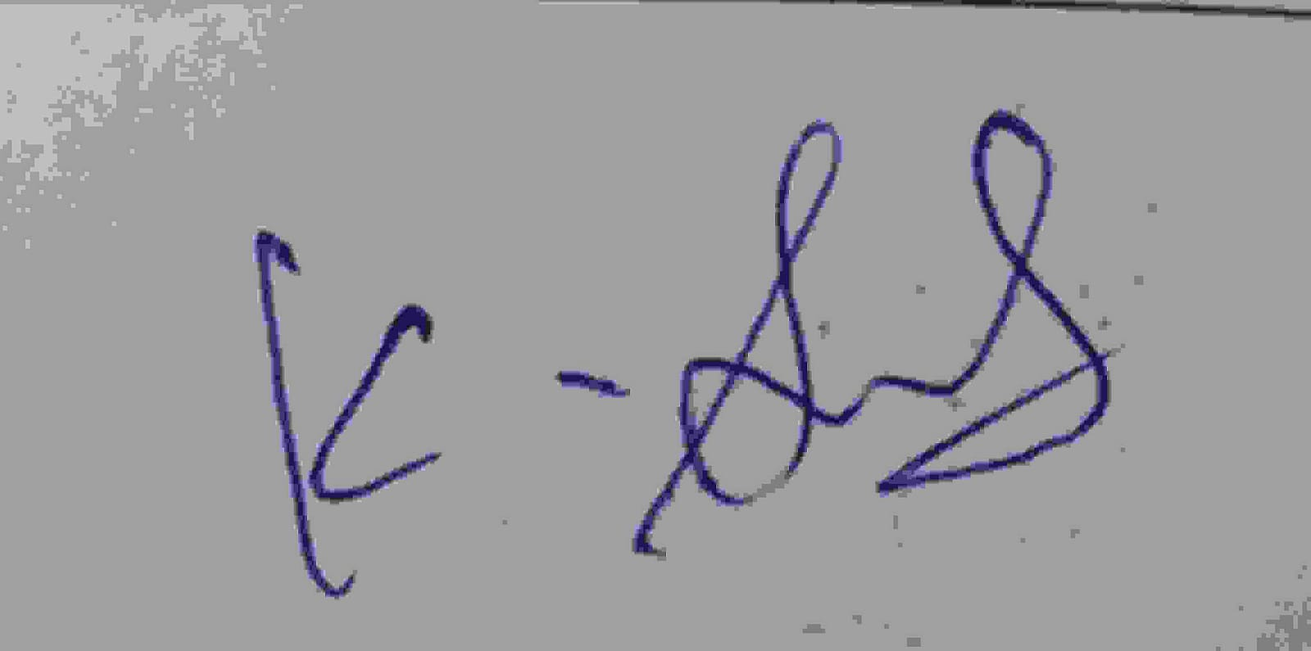
Signature of the student:

RUBRICS FOR CALCULATION:

Criteria | Weightage | Level 4 – Exemplary | Level 3 – Proficient | Level 2 – Developing | Level 1 – Beginning
Understanding of Case | 25 | Thorough understanding; clearly identifies all key issues | Good understanding with most issues identified | Basic understanding; some issues missed | Poor understanding; problem not identified correctly
Application of Concepts | 25 | Effectively applies relevant concepts to analyze the case deeply | Applies appropriate concepts with minor gaps | Limited application of concepts | Fails to apply relevant concepts
Analysis | 20 | In-depth analysis with strong reasoning and insights | Good analysis with logical reasoning | Basic analysis with limited depth | Weak or no analysis; lacks reasoning
Solution Design | 20 | Innovative, feasible solutions with strong justification | Logical solutions with adequate justification | Basic solutions with weak justification | Incorrect or no solution provided
Clarity | 10 | Clear, well-structured, and easy to understand | Organized and understandable presentation | Limited clarity and structure | Poor clarity; difficult to understand

ASSESSMENT TOOL 2 — SOLUTIONS

Question 1
Case: An online shopping platform stores Order(OrderID, CustID, CustName, ProdID, ProdName, Qty, Price). Identify FDs and normalize to 3NF.
Marks: 5 | Bloom's Level: BL2 — Understand

Step 1: Assumptions
- Each order line records one product purchased within an order.
- A single order can contain multiple products, so the natural composite key of the un-normalized relation is (OrderID, ProdID).
- Each customer has one name, and each product has one name and one price.

Step 2: Functional Dependencies
# | Functional Dependency | Interpretation
1 | OrderID → CustID, CustName | An order belongs to exactly one customer.
2 | CustID → CustName | A customer ID uniquely determines the customer name.
3 | ProdID → ProdName, Price | A product ID uniquely determines the product's name and price.
4 | (OrderID, ProdID) → Qty | The quantity ordered depends on both the order and the product together.

Step 3: Normalization Analysis
1NF
All attributes hold single, atomic values, so Order(OrderID, CustID, CustName, ProdID, ProdName, Qty, Price) is already in 1NF. The composite key is (OrderID, ProdID).
2NF — Removing Partial Dependencies
Since the primary key is composite (OrderID, ProdID), every attribute that depends on only part of the key violates 2NF:
- CustID and CustName depend only on OrderID → partial dependency.
- ProdName and Price depend only on ProdID → partial dependency.
- Only Qty genuinely depends on the full key (OrderID, ProdID).
These partial dependencies are removed by decomposing the relation:
- Orders(OrderID, CustID)
- Customers(CustID, CustName)
- Products(ProdID, ProdName, Price)
- OrderDetails(OrderID, ProdID, Qty)
3NF — Checking for Transitive Dependencies
In the decomposed Orders(OrderID, CustID) relation, CustName is no longer present, so the transitive dependency OrderID → CustID → CustName has already been eliminated by placing CustName in the separate Customers relation. No non-key attribute in any relation depends on another non-key attribute, so all four relations are in 3NF (and in fact BCNF, since every determinant is a candidate key).

Step 4: Final 3NF Schema
Relation | Attributes | Primary Key | Foreign Key
Customers | CustID, CustName | CustID | —
Products | ProdID, ProdName, Price | ProdID | —
Orders | OrderID, CustID | OrderID | CustID → Customers
OrderDetails | OrderID, ProdID, Qty | OrderID, ProdID | OrderID → Orders, ProdID → Products

Step 5: Relational Schema Diagram
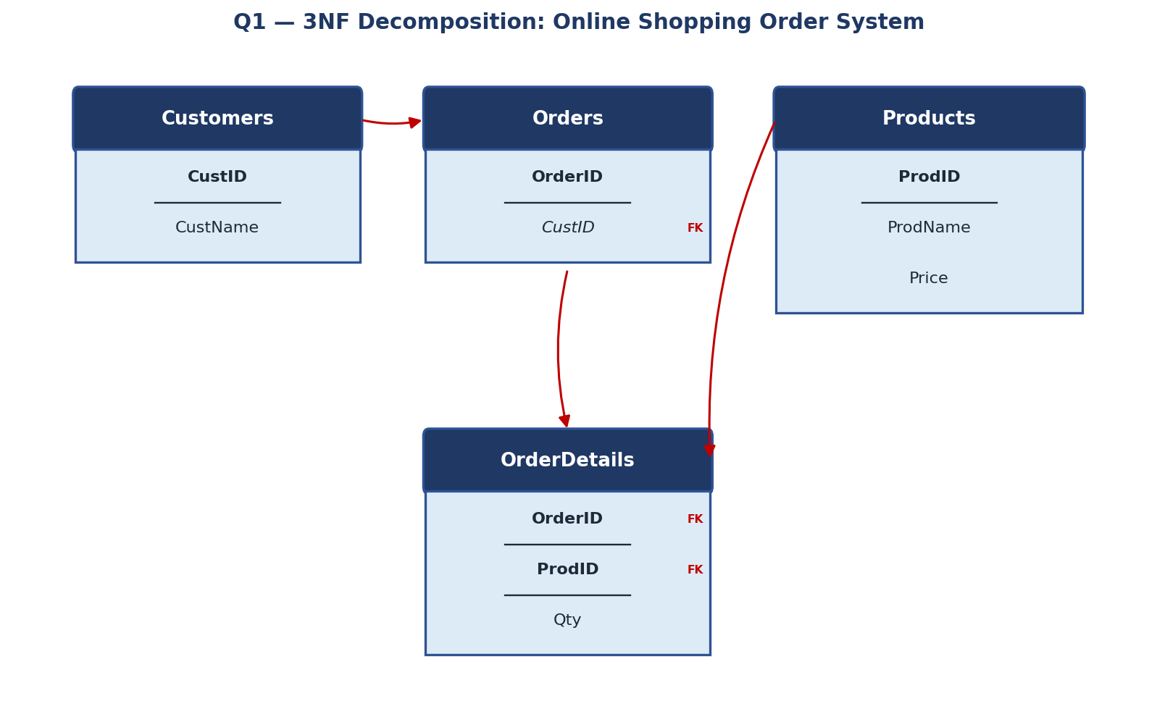
Figure 1.1 — 3NF decomposition of the Order relation into four relations connected by foreign keys.

Conclusion
The original Order relation, which mixed customer, product, and order-line facts in a single table, has been decomposed into four relations — Customers, Products, Orders, and OrderDetails — each of which stores one theme of data. This eliminates redundant storage of customer names and product details across order lines and removes update, insertion, and deletion anomalies, satisfying the requirements of Third Normal Form (3NF).

Question 2
Case: A hospital maintains Patient(PID, PName, DocID, DocName, Specialization, WardNo, WardName). Identify anomalies and normalize to BCNF.
Marks: 5 | Bloom's Level: BL3 — Apply

Step 1: Functional Dependencies
# | Functional Dependency | Interpretation
1 | PID → PName, DocID, WardNo | Each patient has one name, is treated by one doctor, and is admitted to one ward.
2 | DocID → DocName, Specialization | A doctor ID determines the doctor's name and specialization.
3 | WardNo → WardName | A ward number determines the ward name.

Step 2: Anomalies in the Un-normalized Relation
Anomaly Type | Description
Update Anomaly | If Dr. Sharma's specialization changes, every row where DocID = Sharma's ID must be updated; missing even one row causes inconsistent data.
Insertion Anomaly | A newly joined doctor or a newly created ward cannot be recorded until at least one patient is assigned to them, since PID is central to the relation.
Deletion Anomaly | Discharging the only patient under a doctor or in a ward deletes all information about that doctor or ward from the database.

Step 3: Normalization to BCNF
For BCNF, every determinant must be a candidate key. In the un-normalized relation, DocID and WardNo are determinants but are not candidate keys of the whole relation (PID is), so the relation violates BCNF. It is decomposed as follows:
- Patient(PID, PName, DocID, WardNo) — DocID and WardNo become foreign keys.
- Doctor(DocID, DocName, Specialization) — DocID is now a full candidate key.
- Ward(WardNo, WardName) — WardNo is now a full candidate key.
In each resulting relation, the left-hand side of every remaining FD is a candidate key, so all three relations satisfy BCNF.

Step 4: Final BCNF Schema
Relation | Attributes | Primary Key | Foreign Key
Doctor | DocID, DocName, Specialization | DocID | —
Ward | WardNo, WardName | WardNo | —
Patient | PID, PName, DocID, WardNo | PID | DocID → Doctor, WardNo → Ward

Step 5: Relational Schema Diagram
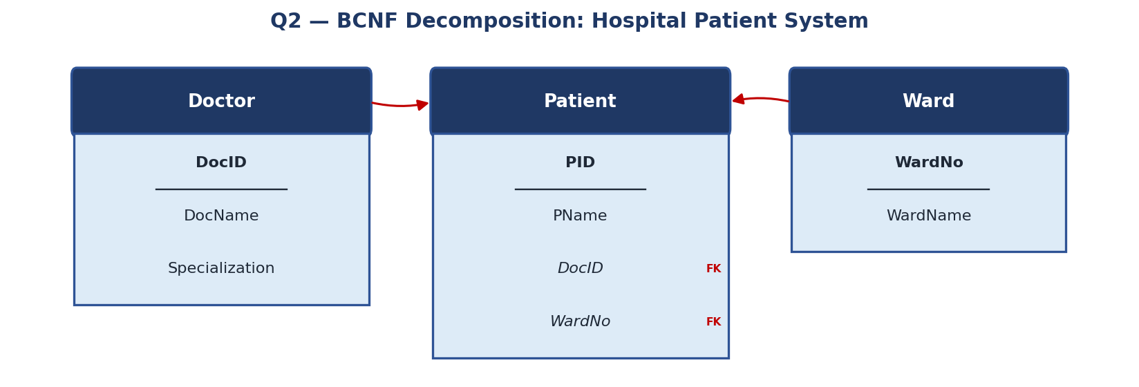
Figure 2.1 — BCNF decomposition of the Patient relation into Doctor, Patient, and Ward.

Conclusion
Separating doctor and ward information from the patient record removes all three anomaly types identified above. Every determinant is now a candidate key in its own relation, so the design is in Boyce-Codd Normal Form (BCNF), the strictest of the classical normal forms based on functional dependencies alone.

Question 3
Case: A university stores Enrollment(SID, SName, CourseID, CourseName, Faculty, Grade). Analyze FDs and apply 2NF decomposition.
Marks: 5 | Bloom's Level: BL3 — Apply

Step 1: Primary Key and Functional Dependencies
A student can enroll in many courses and a course can have many students, so the composite primary key is (SID, CourseID).
# | Functional Dependency | Interpretation
1 | SID → SName | A student ID determines the student's name (partial — depends only on SID).
2 | CourseID → CourseName, Faculty | A course ID determines the course name and the faculty who teaches it (partial — depends only on CourseID).
3 | (SID, CourseID) → Grade | The grade obtained depends on both the student and the specific course (full functional dependency on the whole key).

Step 2: 2NF Violation
Second Normal Form requires that every non-key attribute depend on the entire primary key, not just part of it. Here, SName depends only on SID, and CourseName/Faculty depend only on CourseID — both are partial dependencies on the composite key (SID, CourseID), so the relation violates 2NF.

Step 3: 2NF Decomposition
- Student(SID, SName) — removes the partial dependency SID → SName.
- Course(CourseID, CourseName, Faculty) — removes the partial dependency CourseID → CourseName, Faculty.
- Enrollment(SID, CourseID, Grade) — retains only the attribute (Grade) that is fully dependent on the composite key.
Each resulting relation is now free of partial dependency. There are no transitive dependencies among non-key attributes either (Faculty depends directly on CourseID, not through another non-key attribute), so all three relations also satisfy 3NF.

Step 4: Final Schema
Relation | Attributes | Primary Key | Foreign Key
Student | SID, SName | SID | —
Course | CourseID, CourseName, Faculty | CourseID | —
Enrollment | SID, CourseID, Grade | SID, CourseID | SID → Student, CourseID → Course

Step 5: Relational Schema Diagram
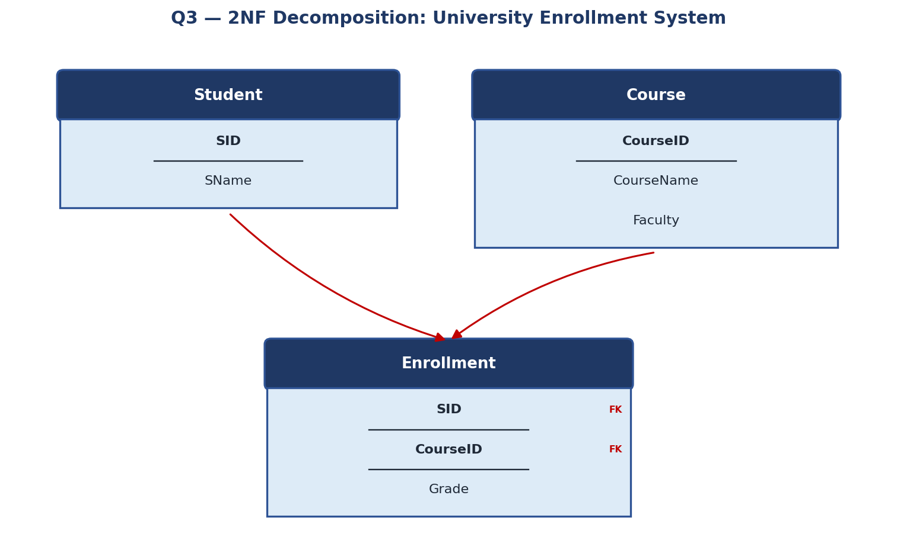
Figure 3.1 — 2NF decomposition of Enrollment into Student, Course, and a bridging Enrollment table.

Conclusion
By separating student attributes and course attributes from the enrollment fact, the design removes redundant repetition of student names and course details across every enrollment row, achieving Second Normal Form (2NF) while also satisfying 3NF.

Question 4
Case: Booking(FlightNo, PassID, PassName, Seat, DeptCity, ArrCity, Date). Normalize up to BCNF.
Marks: 5 | Bloom's Level: BL3 — Apply

Step 1: Assumptions and Primary Key
- A flight number operates on multiple dates, and on each date it carries multiple passengers, so the composite key of the raw relation is (FlightNo, Date, PassID).
- A given seat on a given flight/date can be held by only one passenger.

Step 2: Functional Dependencies
# | Functional Dependency | Interpretation
1 | FlightNo → DeptCity, ArrCity | A flight number determines its fixed departure and arrival cities (the route).
2 | PassID → PassName | A passenger ID determines the passenger's name.
3 | (FlightNo, Date, PassID) → Seat | The seat allotted depends on the flight, the date of travel, and the passenger together.

Step 3: Normalization to BCNF
FlightNo → DeptCity, ArrCity and PassID → PassName are both determinants that are not candidate keys of the whole relation, so the un-normalized Booking relation violates BCNF. Decomposing along these dependencies:
- Flight(FlightNo, DeptCity, ArrCity) — FlightNo is a full candidate key here.
- Passenger(PassID, PassName) — PassID is a full candidate key here.
- Booking(FlightNo, Date, PassID, Seat) — the only remaining FD is the composite key determining Seat, so this relation is already in BCNF.

Step 4: Final BCNF Schema
Relation | Attributes | Primary Key | Foreign Key
Flight | FlightNo, DeptCity, ArrCity | FlightNo | —
Passenger | PassID, PassName | PassID | —
Booking | FlightNo, Date, PassID, Seat | FlightNo, Date, PassID | FlightNo → Flight, PassID → Passenger

Step 5: Relational Schema Diagram
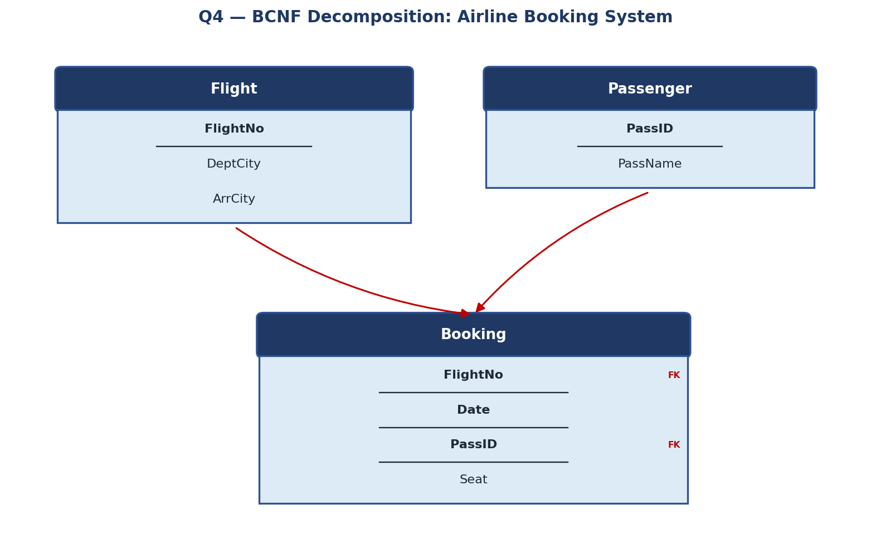
Figure 4.1 — BCNF decomposition of Booking into Flight, Passenger, and a Booking bridge table.

Conclusion
Extracting flight-route data and passenger data into their own relations removes duplicate storage of departure/arrival cities and passenger names for every booking row. Every determinant in the resulting relations is a candidate key, so the design satisfies BCNF.

Question 5
Case: Analyze an HR system schema for a multinational company. Identify all functional and transitive dependencies and normalize to 3NF.
Marks: 5 | Bloom's Level: BL2 — Understand

Step 1: Assumed Schema
Employee(EmpID, EmpName, DeptID, DeptName, DeptLocation, MgrID, MgrName, Salary)

Step 2: Functional Dependencies
# | Functional Dependency | Interpretation
1 | EmpID → EmpName, DeptID, MgrID, Salary | An employee ID determines the employee's own attributes.
2 | DeptID → DeptName, DeptLocation | A department ID determines the department name and its location.
3 | MgrID → MgrName | A manager's ID (itself an employee) determines the manager's name.

Step 3: Transitive Dependencies
A transitive dependency exists when a non-key attribute depends on another non-key attribute rather than directly on the primary key:
- EmpID → DeptID → DeptName, DeptLocation — DeptName and DeptLocation are transitively dependent on EmpID through DeptID.
- EmpID → MgrID → MgrName — MgrName is transitively dependent on EmpID through MgrID.
These transitive dependencies violate 3NF, which requires that every non-key attribute depend directly on the primary key and not on another non-key attribute.

Step 4: 3NF Decomposition
- Department(DeptID, DeptName, DeptLocation) — removes the transitive dependency through DeptID.
- Manager(MgrID, MgrName) — removes the transitive dependency through MgrID.
- Employee(EmpID, EmpName, DeptID, MgrID, Salary) — retains only attributes that depend directly on EmpID.

Step 5: Final 3NF Schema
Relation | Attributes | Primary Key | Foreign Key
Department | DeptID, DeptName, DeptLocation | DeptID | —
Manager | MgrID, MgrName | MgrID | —
Employee | EmpID, EmpName, DeptID, MgrID, Salary | EmpID | DeptID → Department, MgrID → Manager

Step 6: Relational Schema Diagram
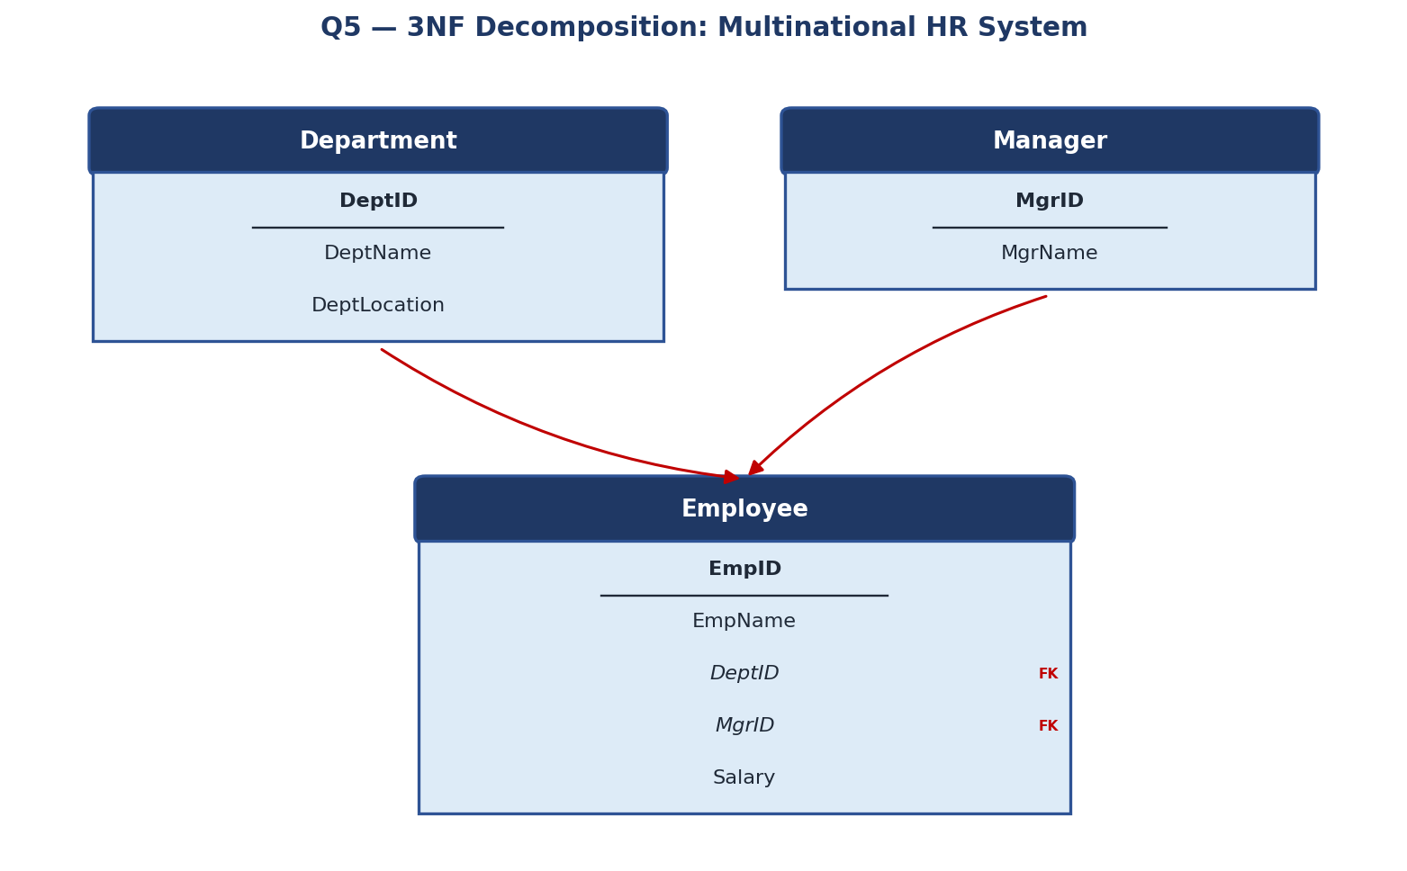
Figure 5.1 — 3NF decomposition of the Employee relation, removing transitive dependencies via Department and Manager.

Conclusion
Both transitive dependencies are eliminated by moving department and manager attributes into their own relations, leaving Employee with only attributes that depend directly and fully on EmpID. The resulting three-relation design satisfies 3NF.

Question 6
Case: Library(MemberID, MemberName, BookID, Title, Author, Genre, BorrowDate). Identify MVDs and decompose to 4NF.
Marks: 5 | Bloom's Level: BL3 — Apply

Step 1: Assumptions
- A book can have multiple authors and can be classified under multiple genres, and these two facts are independent of each other.
- A member can borrow many books over time.

Step 2: Multi-Valued Dependencies (MVDs)
# | Functional Dependency | Interpretation
1 | BookID ↠ Author | For a given book, the set of authors is independent of the set of genres associated with it.
2 | BookID ↠ Genre | For a given book, the set of genres is independent of the set of authors.
3 | MemberID ↠ BookID | A member is independently associated with the set of books they borrow.
The relation already satisfies BCNF with respect to simple functional dependencies (BookID → Title is the only classical FD), but it still exhibits a multi-valued dependency: for a fixed BookID, the Author values and Genre values vary independently, causing every Author to be paired redundantly with every Genre in the un-normalized table.

Step 3: 4NF Violation and Decomposition
Fourth Normal Form requires that a relation have no non-trivial multi-valued dependency unless the determinant is a superkey. Since Author and Genre vary independently for the same BookID, the relation is split so that each independent multi-valued fact is stored in its own relation:
- Member(MemberID, MemberName)
- Book(BookID, Title)
- BookAuthor(BookID, Author) — captures the Author MVD.
- BookGenre(BookID, Genre) — captures the Genre MVD.
- Borrow(MemberID, BookID, BorrowDate) — captures the borrowing transaction.

Step 4: Final 4NF Schema
Relation | Attributes | Primary Key | Foreign Key
Member | MemberID, MemberName | MemberID | —
Book | BookID, Title | BookID | —
BookAuthor | BookID, Author | BookID, Author | BookID → Book
BookGenre | BookID, Genre | BookID, Genre | BookID → Book
Borrow | MemberID, BookID, BorrowDate | MemberID, BookID | MemberID → Member, BookID → Book

Step 5: Relational Schema Diagram
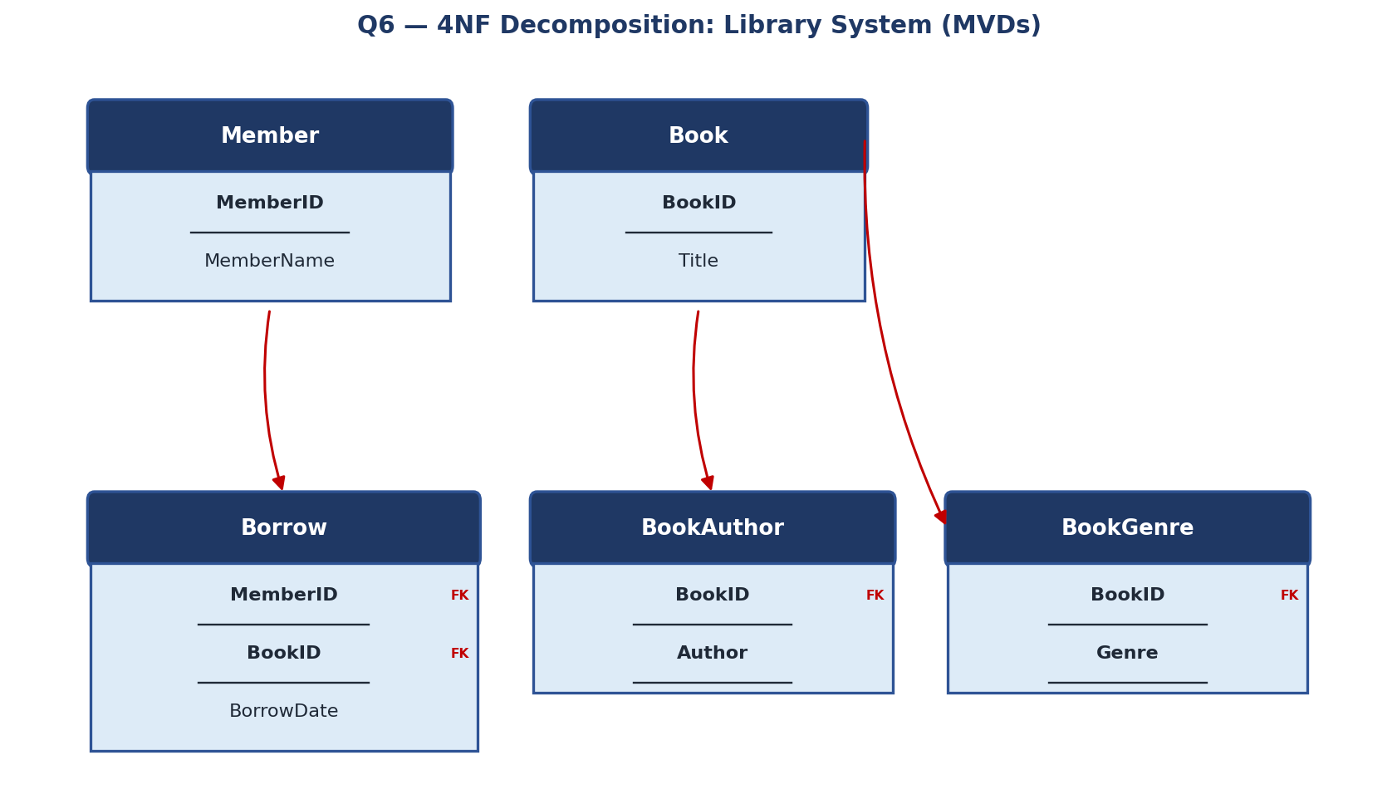
Figure 6.1 — 4NF decomposition separating the independent multi-valued facts Author and Genre from Book.

Conclusion
Splitting BookAuthor and BookGenre into separate relations removes the redundant cross-product of authors and genres that would otherwise appear for every book, satisfying Fourth Normal Form (4NF).

Question 7
Case: Analyze a telecom billing schema and identify all candidate keys, primary keys, and functional dependencies before normalization.
Marks: 5 | Bloom's Level: BL2 — Understand

Step 1: Assumed Schema
Billing(CustID, CustName, PhoneNo, PlanID, PlanName, PlanCost, BillMonth, CallDuration, Amount)
- Each customer can own multiple phone connections (PhoneNo).
- Each phone connection is billed separately every month, so a bill record is identified by the connection and the month.

Step 2: Functional Dependencies
# | Functional Dependency | Interpretation
1 | PhoneNo → CustID, PlanID | Each phone number belongs to one customer and is subscribed to one plan.
2 | CustID → CustName | A customer ID determines the customer's name.
3 | PlanID → PlanName, PlanCost | A plan ID determines the plan name and its monthly cost.
4 | (PhoneNo, BillMonth) → CallDuration, Amount | The total call duration and billed amount for a connection depend on both the phone number and the billing month.

Step 3: Candidate Keys
A candidate key must functionally determine every other attribute in the relation. Testing the attribute combinations:
- (PhoneNo, BillMonth):
PhoneNo → CustID, PlanID → CustName, PlanName, PlanCost, and (PhoneNo, BillMonth) → CallDuration, Amount. Together this composite determines every attribute in the relation, so (PhoneNo, BillMonth) is a candidate key.
No smaller attribute combination determines all attributes (PhoneNo alone cannot determine CallDuration/Amount, and BillMonth alone determines nothing), so (PhoneNo, BillMonth) is the only candidate key.

Step 4: Primary Key
Key Type | Attribute(s) | Justification
Candidate Key | (PhoneNo, BillMonth) | The only minimal combination that determines all other attributes.
Primary Key | (PhoneNo, BillMonth) | Selected as the primary key since it is the sole candidate key.
Partial Determinants (not keys) | PhoneNo, CustID, PlanID | Each determines some attributes but not the whole relation, so none qualifies alone as a candidate key.

Step 5: Functional Dependency Diagram
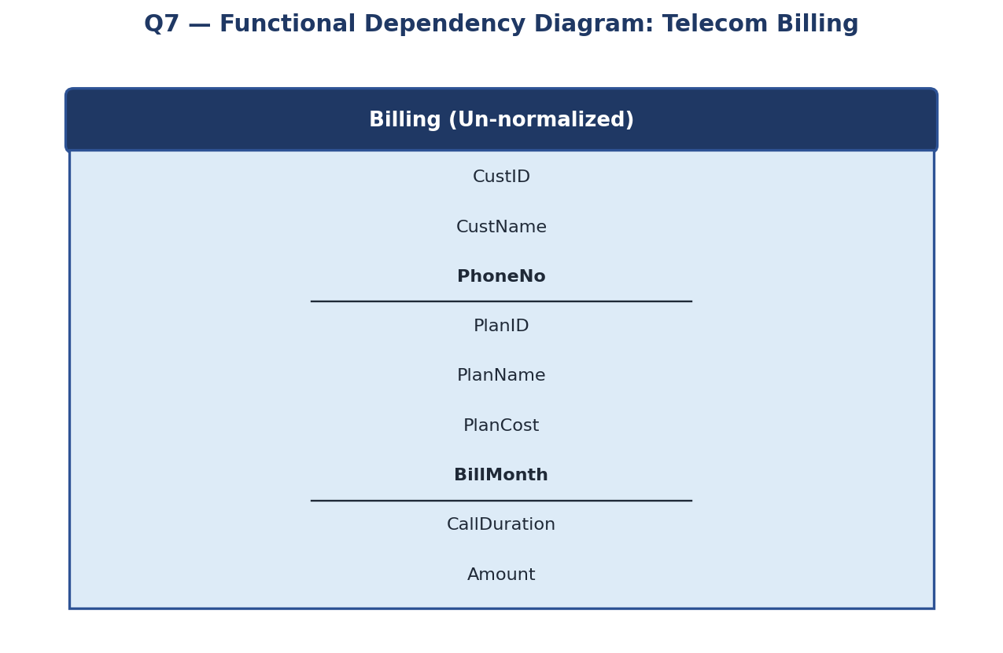
Figure 7.1 — Un-normalized Billing relation with primary key (PhoneNo, BillMonth) underlined.

Note on Normalization
This question asks only for the FD and key analysis prior to normalization. Observe, however, that PhoneNo → CustID, PlanID and CustID → CustName, PlanID → PlanName, PlanCost are partial and transitive dependencies on the composite key (PhoneNo, BillMonth) — this same schema would be decomposed into Customer, Plan, Connection, and MonthlyBill relations using the same technique demonstrated in Questions 1–5 if full normalization were required.

Conclusion
The telecom billing relation has exactly one candidate key, (PhoneNo, BillMonth), which is therefore chosen as the primary key. All other attributes are dependent, directly or transitively, on this composite key.

Question 8
Case: A retail inventory system has Product(PID, PName, SupplierID, SupplierName, Category, Price, Warehouse). Apply complete normalization.
Marks: 5 | Bloom's Level: BL3 — Apply

Step 1: Functional Dependencies
# | Functional Dependency | Interpretation
1 | PID → PName, SupplierID, Category, Price, Warehouse | A product ID determines all of the product's own attributes.
2 | SupplierID → SupplierName | A supplier ID determines the supplier's name (transitive dependency on PID).

Step 2: Normalization Walkthrough
1NF
All attributes are atomic and PID is a single-column key, so the relation is in 1NF.
2NF
Since the primary key (PID) is a single attribute, no partial dependency is possible, so the relation automatically satisfies 2NF.
3NF
SupplierName depends on SupplierID, which in turn depends on PID — this is a transitive dependency (PID → SupplierID → SupplierName), which violates 3NF.
BCNF
Removing the transitive dependency by extracting Supplier(SupplierID, SupplierName) leaves Product(PID, PName, SupplierID, Category, Price, Warehouse), where PID is the only determinant and is already the primary key. Both resulting relations therefore satisfy BCNF as well as 3NF.

Step 3: Final Schema
Relation | Attributes | Primary Key | Foreign Key
Supplier | SupplierID, SupplierName | SupplierID | —
Product | PID, PName, SupplierID, Category, Price, Warehouse | PID | SupplierID → Supplier

Step 4: Relational Schema Diagram
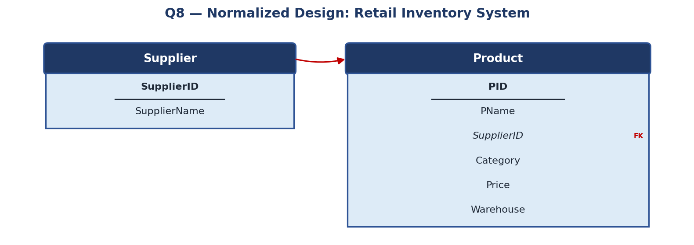
Figure 8.1 — Complete normalization of Product, separating Supplier into its own relation.

Conclusion
Extracting Supplier removes the transitive dependency and the redundant repetition of a supplier's name across every product they supply. The final two-relation design is fully normalized up to BCNF.

Question 9
Case: Study the given poorly normalized schema for a School ERP and propose a fully normalized design up to BCNF with justification.
Marks: 5 | Bloom's Level: BL3 — Apply

Step 1: Poorly Normalized Schema
SchoolERP(StudentID, StudentName, ClassID, ClassName, TeacherID, TeacherName, Subject, ParentName, ParentContact, FeeAmount, FeeStatus)
This single, wide relation mixes five distinct themes — student demographics, class information, teacher information, subject-teaching assignments, and fee records — inside one table, which is the classic symptom of a poorly normalized design.

Step 2: Functional Dependencies
# | Functional Dependency | Interpretation
1 | StudentID → StudentName, ClassID, ParentName, ParentContact, FeeAmount, FeeStatus | A student's personal, class, parent, and fee details are all determined by the student's ID.
2 | ClassID → ClassName | A class ID determines the class name.
3 | (ClassID, Subject) → TeacherID, TeacherName | The teacher assigned to teach a subject depends on both the class and the subject.
4 | TeacherID → TeacherName | A teacher ID determines the teacher's name.

Step 3: Problems Identified
Issue | Explanation
Redundancy | ClassName is repeated for every student in the class; TeacherName is repeated for every class/subject the teacher handles.
Update anomaly | Renaming a class or correcting a teacher's name requires updating many student rows.
Insertion anomaly | A new class, teacher, or subject assignment cannot be recorded without an existing student row.
Deletion anomaly | Removing the last student of a class deletes all record of that class and its teaching assignments.
Mixed granularity | Student-level facts, class-level facts, and subject/teacher assignments are all forced into one row per student, even though they change at different rates.

Step 4: BCNF Decomposition
Grouping attributes by the determinant that governs them (each of which becomes a candidate key in its own relation):
- Class(ClassID, ClassName)
- Teacher(TeacherID, TeacherName)
- ClassSubjectTeacher(ClassID, Subject, TeacherID) — models which teacher takes which subject for which class.
- Student(StudentID, StudentName, ClassID, ParentName, ParentContact)
- Fee(StudentID, FeeAmount, FeeStatus)
In every relation above, the left-hand side of each remaining functional dependency is the full primary key, so every relation satisfies BCNF.

Step 5: Final BCNF Schema
Relation | Attributes | Primary Key | Foreign Key
Class | ClassID, ClassName | ClassID | —
Teacher | TeacherID, TeacherName | TeacherID | —
ClassSubjectTeacher | ClassID, Subject, TeacherID | ClassID, Subject | ClassID → Class, TeacherID → Teacher
Student | StudentID, StudentName, ClassID, ParentName, ParentContact | StudentID | ClassID → Class
Fee | StudentID, FeeAmount, FeeStatus | StudentID | StudentID → Student

Step 6: Relational Schema Diagram
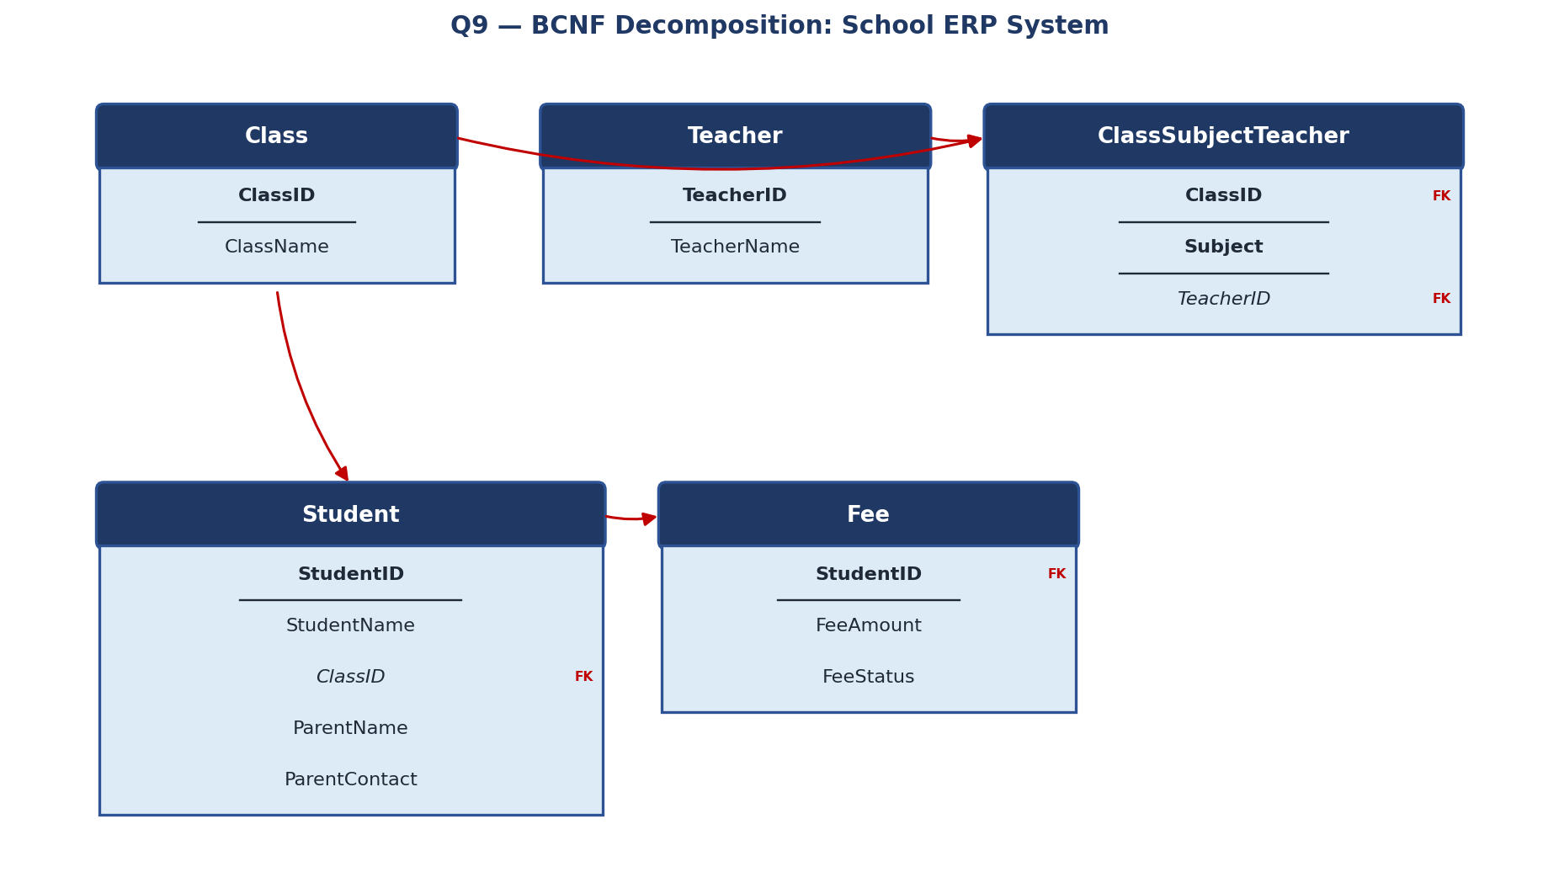
Figure 9.1 — Fully normalized School ERP design: five BCNF relations linked by foreign keys.

Justification / Conclusion
Separating class, teacher, teaching-assignment, student, and fee data into distinct relations means each fact is stored exactly once, teachers and classes can be added independently of student enrolment, and updates to a class name or teacher name touch only a single row. This design satisfies BCNF and directly resolves every anomaly identified in Step 3.

Question 10
Case: Given a movie streaming platform schema, identify join dependencies and decompose to 5NF with lossless-join verification.
Marks: 5 | Bloom's Level: BL3 — Apply

Step 1: Assumed Schema
Streaming(Actor, Movie, Platform) — records that a given Actor appears in a given Movie which is available on a given Platform.
This is the classical ternary-relationship scenario used to illustrate Fifth Normal Form: the relation is already in BCNF (there are no non-trivial functional dependencies at all — the only key is the full attribute set (Actor, Movie, Platform)), yet it can still contain redundancy caused by a join dependency.

Step 2: Identifying the Join Dependency
Suppose the following business rule holds: "If an actor appears in a movie, and that movie is available on a platform, and that actor's other movies are also available on that same platform (i.e., the association is fully independent pairwise), then the triple (Actor, Movie, Platform) is valid." This is expressed as the join dependency:
JD ( R1(Actor, Movie), R2(Movie, Platform), R3(Actor, Platform) )
This states that the original ternary relation can be losslessly reconstructed by natural-joining its three binary projections. When such a non-trivial JD holds and is not implied by the candidate key alone, the relation violates 5NF.

Step 3: Decomposition to 5NF
- ActorMovie(Actor, Movie) — which actors appear in which movies.
- MoviePlatform(Movie, Platform) — which movies are available on which platforms.
- ActorPlatform(Actor, Platform) — which actors have content on which platforms.

Step 4: Lossless-Join Verification
To verify losslessness, the three projections are natural-joined back together and compared with the original relation using the tableau method:
- Project the original Streaming relation onto (Actor, Movie), (Movie, Platform), and (Actor, Platform) to obtain ActorMovie, MoviePlatform, and ActorPlatform.
- Natural-join ActorMovie with MoviePlatform on the common attribute Movie, producing candidate triples (Actor, Movie, Platform).
- Natural-join the result with ActorPlatform on the common attributes (Actor, Platform); only the triples that satisfy all three pairwise associations survive.
- If every triple in this final join exactly matches a triple in the original Streaming relation (no spurious rows are introduced and none are lost), the decomposition is lossless.
Under the stated business rule — that the ternary fact is fully determined by its three pairwise projections — this three-way join reproduces exactly the original relation with no spurious tuples, confirming a lossless-join decomposition and satisfying the definition of 5NF (every join dependency is implied by the candidate keys of the projected relations).

Step 5: Final 5NF Schema
Relation | Attributes | Primary Key | Foreign Key
ActorMovie | Actor, Movie | Actor, Movie | —
MoviePlatform | Movie, Platform | Movie, Platform | —
ActorPlatform | Actor, Platform | Actor, Platform | —

Step 6: Relational Schema Diagram
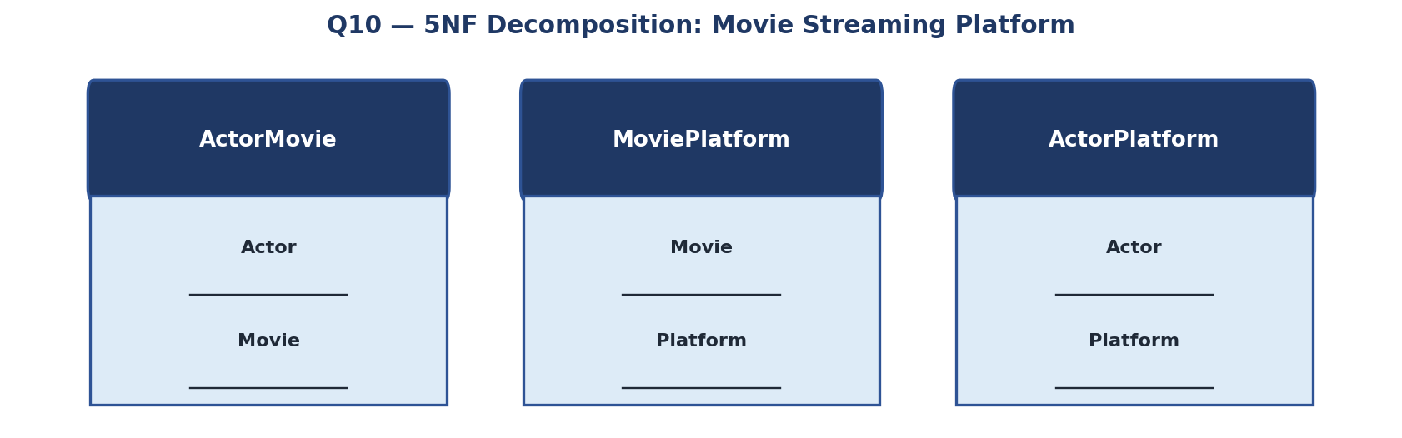
Figure 10.1 — 5NF decomposition of the ternary Streaming relation into three binary projections.

Conclusion
Decomposing the ternary Streaming relation into ActorMovie, MoviePlatform, and ActorPlatform removes the redundancy caused by the join dependency while guaranteeing that the original data can always be reconstructed by joining the three projections back together — satisfying Fifth Normal Form (5NF), the highest classical normal form.

